**How to:**

**Use RSR RE20 respirator**

# Summary of developments

**Version 1.0**

17/07/2020 : M. JACONELLI - Initial version

**Table of contents**

1. Summary of developments 1

2. Prerequisite 3

2.1 Document objective 3

2.2 Before starting… 3

3. RSR RE20 respirator use 4

3.1 RSR RE20 respirator connections 4

3.2 RSR RE20 respirator start 7

# Prerequisite

## Document objective

This document is intended to explain how to use RSR RE20 respirator.

## Before starting…

In order to use RSR RE20 respirator, make sure you have:

* A RSR RE20 respirator
* An artificial lung
* A “Y” fitting (for connection between lung and respirator)
* A plug for O2 input

# RSR RE20 respirator use

## RSR RE20 respirator connections

The artificial lung has to be connected to the respirator. To do so, it’s connected to the surgical pipes through the “Y” fitting. It corresponds to the following picture:

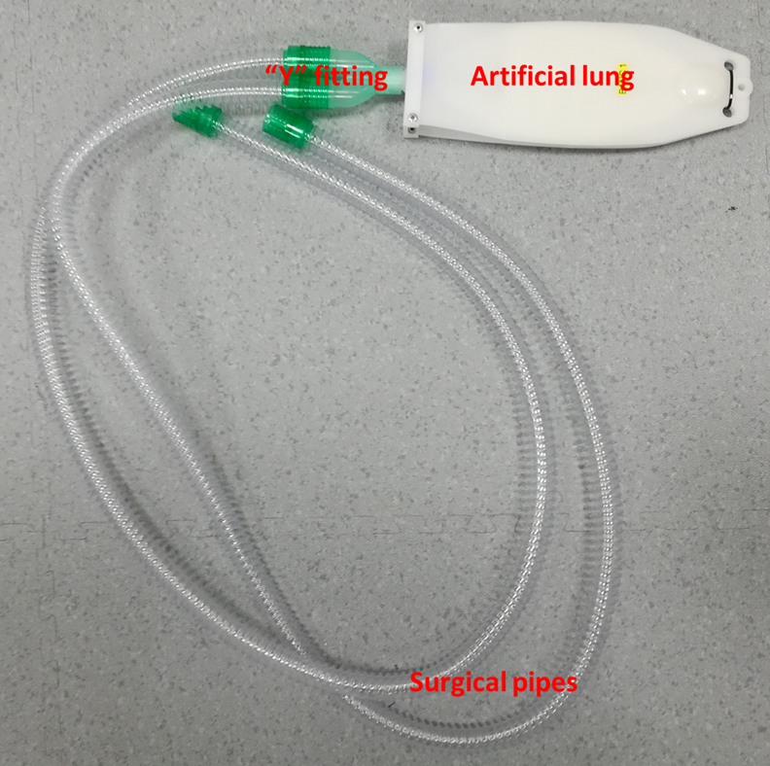

The surgical pipes and O2 plug can now be connected to the RSR RE20 respirator front panel, according to the following picture:

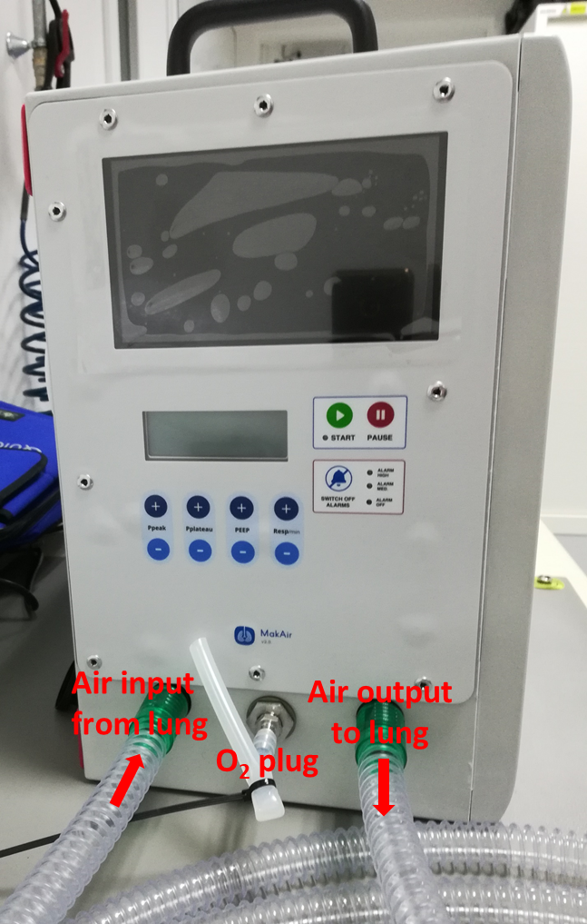

**Remark:** the 2 surgical pipes can be inverted when connecting to RSR RE20 respirator, there is no difference.

Finally, RSR RE20 respirator can be plugged to electrical network.

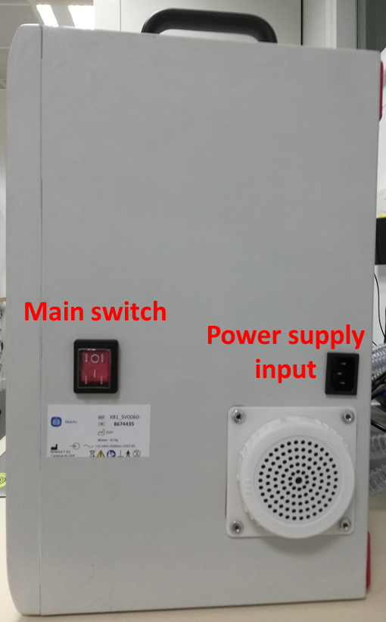

## RSR RE20 respirator start

When RSR RE20 respirator is plugged to electrical network, it can be switched on, by pressing the main switch located on the back panel (see above picture).

Once RSR RE20 respirator is switched on, it goes through an initialization.

During this phase, LCD display displays the software version number:

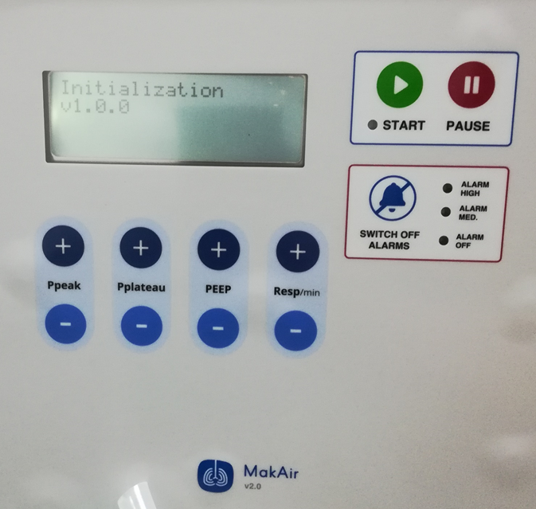

When initialization is finished, system goes into “wait mode”, respirator is ready to be started:

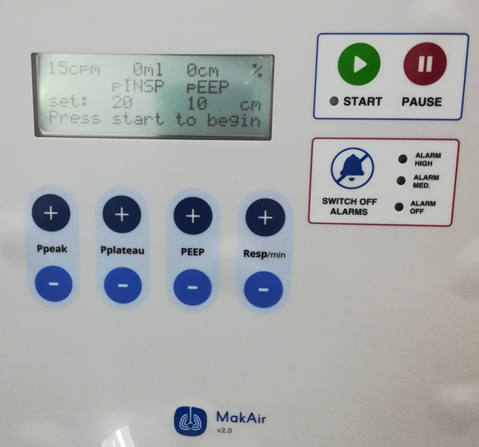

Here is explanation of the LCD display content in wait mode:

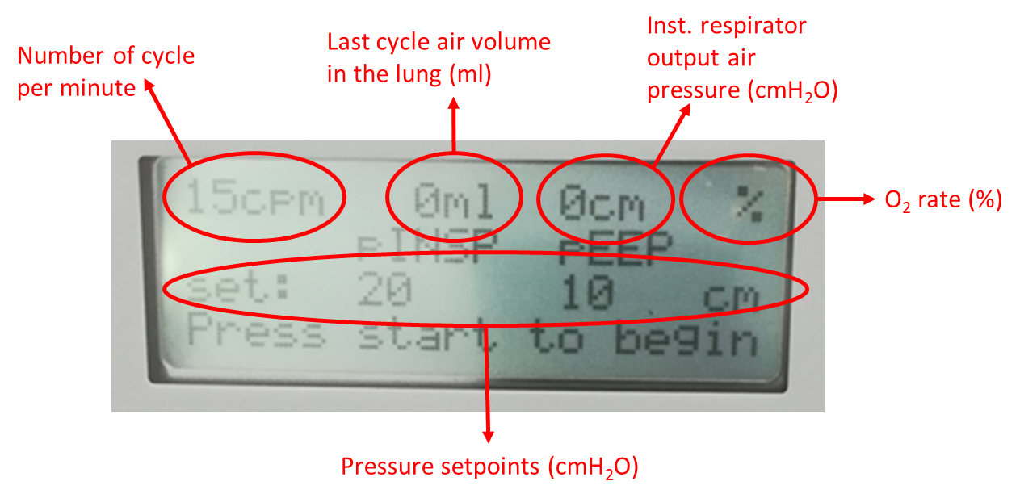

**Remark:**

* Number of respiration cycles per minute can be set with “**Resp**/min” buttons
* Pressure at the end of inhalation phase can be set with “**Pplateau**” buttons
* Pressure at the end of exhalation phase can be set with “**PEEP**” buttons
* “Ppeak” and “SWITCH OFF ALARMS” buttons are not used
* Start and alarms LED are also not used

To start the RSR RE20 respirator, just press the button 1 time.

Once RSR RE20 respirator is started, it goes to “Cycle mode” and displays the following:

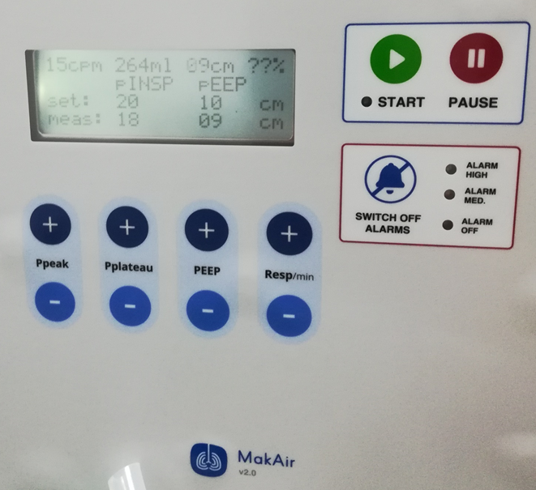

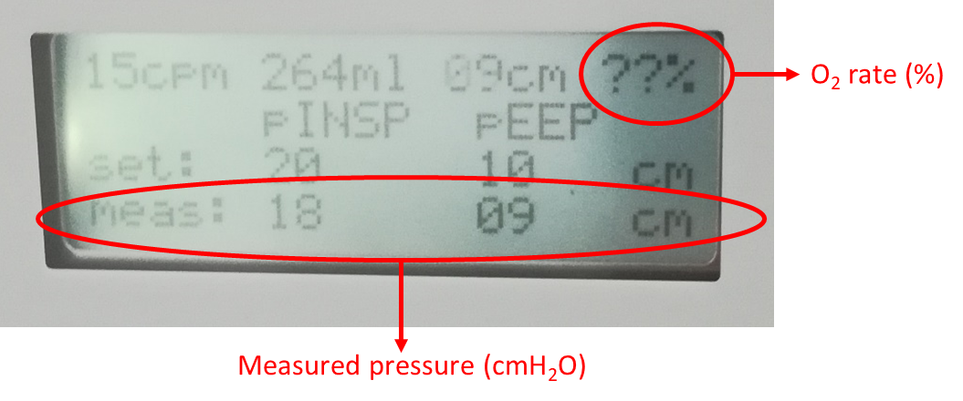

**Remark:**

* O2 rate displays “??” because this functionality is not implemented in v1.0.0 software.
* At the beginning, system will set an alarm (code 22), which is displayed on the second line of the LCD display, this alarm means that pressure in the system didn’t reached the setpoint. This is normal and will disappear once system has reached the pressure setpoint.

To stop the RSR RE20 respirator, just press the button **2 times**.

When stopped, the system goes back to “Wait mode”, the RSR RE20 respirator can then be switched off using the main switch on the back panel.